Year 8 Science Stage 4 Course
Modified by Mr Danic and Mr Planting, Forces Part 1

Acknowledgments

Sydney Distance Education High School gratefully acknowledges the following owners of copyright material.
Board of Studies NSW Science K-10 Syllabus 2013 NSW Department of Education and Communities Centre for Learning Innovation
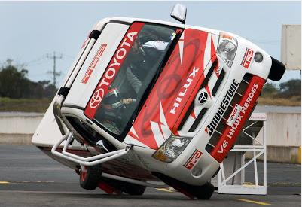
NOTICE ON MATERIAL REPRODUCED OR COMMUNICATED UNDER STATUTORY TEXT AND ARTISTIC LICENCE
FORM OF NOTICE FOR PARAGRAPH 135ZXA(a) OF COPYRIGHT ACT 1968
COMMONWEALTH OF AUSTRALIA
Copyright Regulations 1969 WARNING
This material has been reproduced and communicated to you by or on behalf of Sydney Distance Education High School pursuant to Part VB of the Copyright Act 1960 (the Act).
The material in this communication may be subject to copyright under the Act. Any further reproduction or communication of this material by you may be subject to copyright protection regulation under the Act.
Do not remove this notice.

Copyright of this material is reserved to the Crown in the right of the State of New South Wales. Reproduction or transmittal in whole, or in part, other than in accordance with provisions of the Copyright Act 1968 is prohibited without the written authority of Sydney Distance Education High School.

Glossary

Read through this list of terms and their meanings which are introduced throughout this unit.

Term | Meaning
balanced force | When there is no net force acting on an object.
change | To make or become different; to alter.
force | Anything that causes a change in the motion or shape of an object.
force meter | A type of spring balance used to determine the size of a force.
friction | A force that slows things down or stops things moving.
gravitational force | A force pulling in the direction towards the centre of the Earth.
gravity | A force that attracts objects to each other.
mass | The amount of matter in an object, measured in kilograms.
newtons (N) | The unit we use to measure a force.
unbalanced force | When there is a net force acting on an object causing a change in motion.
weight | A force measured in newtons (N)

Lesson 1 – Types of Forces
Different types of forces affect the way things move. They even affect the way things stay still. Forces act on all things at all times.
A force is anything that causes a change in the motion or shape of an object.
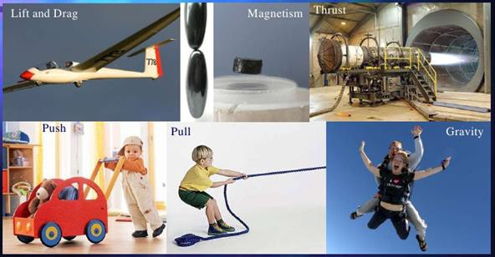
Describe in your own words the term ‘force’. ____________________________________
_____________________________________________________________________


Forces
Forces are involved in anything we do.


- Our muscles apply force to allow us to move.


- A pot plant hanging on a hook applies a force on the hook.
- A car applies force on the road to allow the car to move.
Push, Pull and Twist Forces
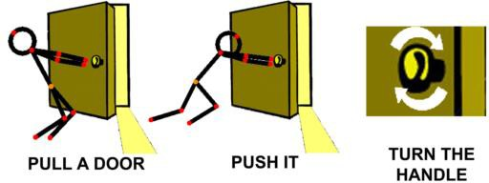
A force can be a push, a pull or a twist on an object.
e.g. Push | e.g. Pull | e.g. Twist
- Writing on paper  - Typing on a keyboard | - Tug-of-war  - Zipping up a jacket | - Opening a door  - Unscrewing a bottle

- Match the pictures below to the correct force – push, pull, twist
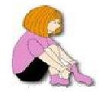
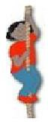
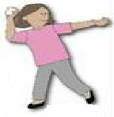
Opening a Jar Throwing a ball Climbing a rope Putting on socks
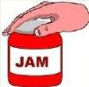

- Read the sentences in the box below. Highlight the words that relate to a push, pull or twist force. Underline each force mentioned that is a PUSH, PULL or TWIST.
Milly opened the fridge and grabbed a can of soft drink. She closed the fridge, opened the can and drank it. The she crushed the can and threw it into the recycling bin

Forces Cause Change

Forces can cause changes. Forces can result in a change in:
• speed (eg making a car go faster by pusher the accelerator pedal)
• direction (eg turning the wheel of a car allows the car to turn a corner)
• shape (eg you can hammer a lump of copper into a flat sheet).
Forces can:
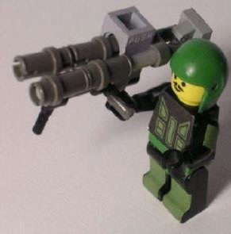  Start an object moving | 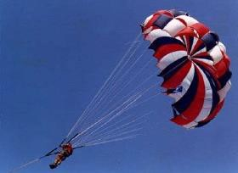  Change an objects speed | 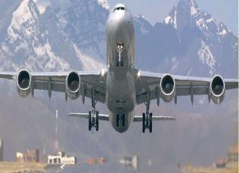  Change an objects direction | 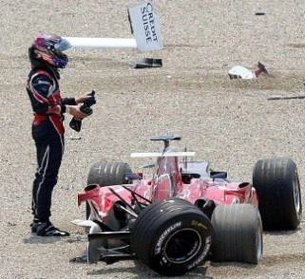  Change an objects shape

What type of change (speed, direction, shape) is occurring in each of these situations.
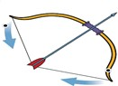
- A bow being pulled back before the arrow is released.

_________________________________________________________

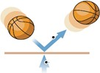
- A basketball bouncing on the ground.

_________________________________________________________

- A football being kicked from the ground.
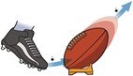
______________________________________________________________
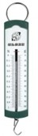
Lesson 2 – The Size of Force

The size of a force can be measured using instruments. A force meter is a type of spring balance. When an object is hung from the hook of the balance the spring stretches under the weight of the object.
The bigger the force applied, the longer the string stretches and the bigger the reading.
The unit of force is called the newton, and it has the symbol N.

100N is a bigger force than 5N.

The weight of an object is caused by the pull of gravity. An object with a larger weight will have a bigger reading on a force meter.

Read the force, in newtons (N), on the force meters below.
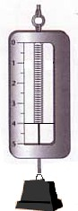
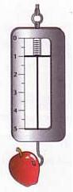
- How many Newtons of force is the:
Apple applying? ______N
Paper Weight applying? _____N

- Which object (Apple or Paper Weight) has a larger weight?
_________________________________

*******MAKING YOUR OWN FORCE METRE with elastic and water*************
Experiment – Measuring Forces

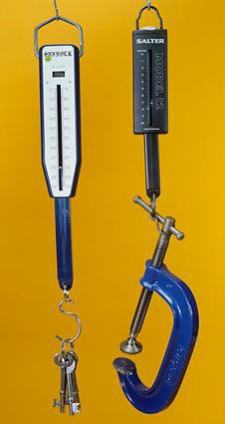
Aim: To investigate the amount of force required to complete different tasks.
Materials: Force meter, pencil case, door, shoe.

Method
1. Lift your pencil case with the force meter.
2. Record the force needed in newtons in the table below.
3. Open a door with the force meter.
4. Record the force needed in newtons in the table below.
5. Drag your shoe along the ground with the force meter.
6. Record the force needed in newtons in the table below.

Results
Task | Force needed in Newtons (N)
Lifting a pencil case
Opening a door
Dragging a shoe on the ground

Conclusion
The task that needed the greatest force was __________________________________

It needed _____________ Newtons.

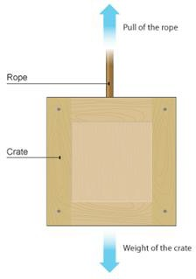
Lesson 3 – Force Diagrams
We can show the forces acting on an object using a force diagram. In a force diagram, each force is shown as a force arrow. An arrow shows:
• the size of the force (the longer the arrow, the bigger the force)
• the direction in which the force acts.
The arrow can be labelled with the name of the force and the size of the force in newtons (N).

*Activity*
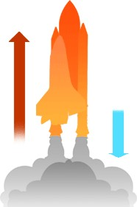
1. Circle the larger force arrow in each picture below.
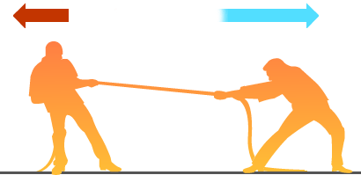

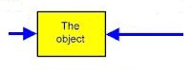

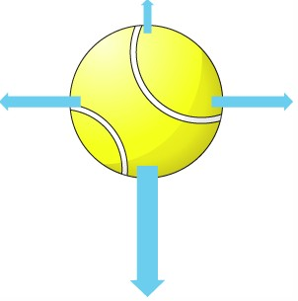
2. The arrows in the picture represent forces acting on a tennis ball.

(a) Circle the largest force.
(b) Which direction do you think the ball will move in? ___________

Balanced Forces
When an object is at rest (not moving, or stationary), there is no net force acting on it.
When forces are balanced, objects remain stationary (still).
This does not mean that there are no forces acting on it. It means that the forces are balanced.
A book resting on a desk has forces acting on it, but there is no movement. The forces on the book are balanced.
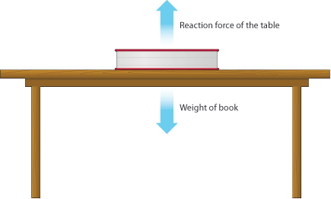
i.e. Gravity is pulling the book down constantly, however the table is resisting this force and pushing up on the book. The forces are BALANCED

If the forces on an object are balanced (or if there are no applied forces acting on it) this is what happens:
• an object that is not moving stays still
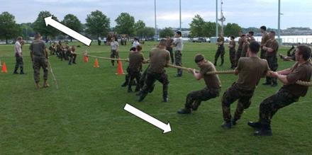
• an object that is moving continues to move at the same speed and in the same direction.
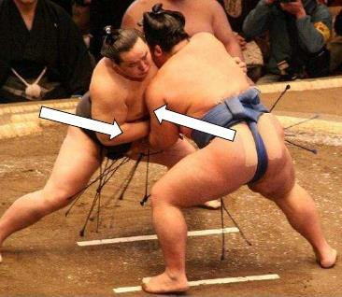
- The force is the rope is equal so both sides cannot move.
- Each Sumo wrestler is applying an equal pushing force, so they stay still

Unbalanced Forces
Unbalanced forces cause a change in motion of an object.
When an object is dropped, its motion increases as it falls from rest. The forces become unbalanced.
When forces are unbalanced the object will move.

If the applied forces on an object are unbalanced this is what happens:
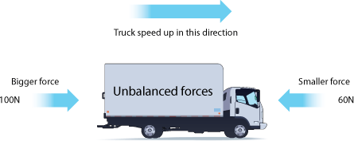
• an object that is not moving starts to move
• an object that is moving changes speed or direction.

Examples of unbalanced forces
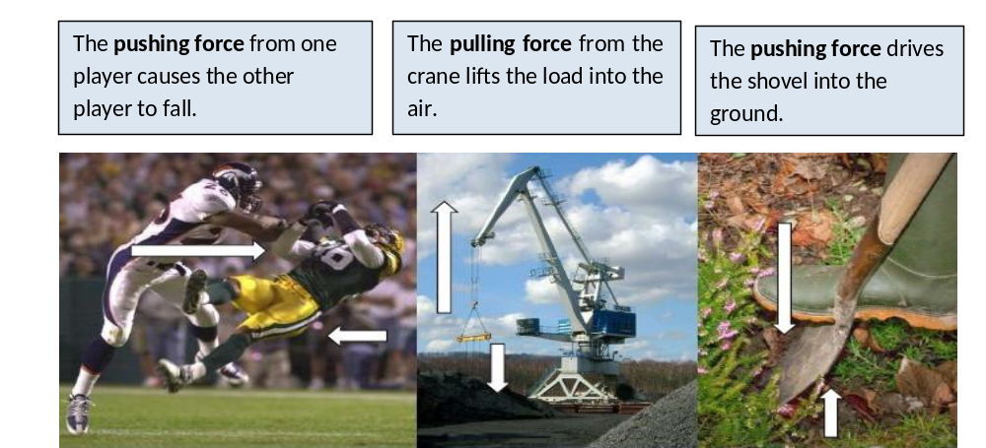

Activity
1. Circle the correct word describing whether the forces are balanced or unbalanced in each of the pictures.
2. For each of the pictures describe which direction the object will move, or whether it will remain stationary (still). The first one has been started for you.

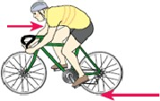
Balanced / unbalanced
The bicycle will ____________________________________________ ________________________________________________________
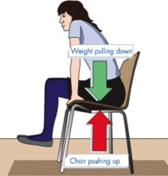
Balanced / unbalanced
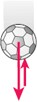
__________________________________________________________ __________________________________________________________
Balanced / unbalanced
________________________________________________________________
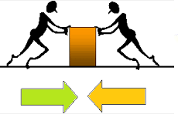
Balanced / unbalanced
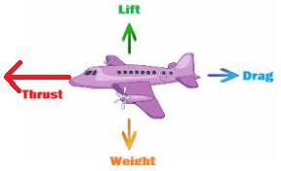
__________________________________________________

Balanced / unbalanced
___________________________________________ ___________________________________________

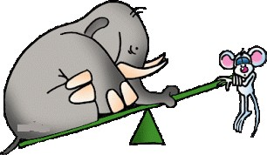
Lesson 4 – Weight and Mass
People often confuse mass and weight.
• Weight is a force and is measured in newtons (N)
• Mass is measured in kilograms (kg) or grams (g)

The mass of an object is the amount of matter or ‘stuff’ it contains. The more matter an object contains, the greater its mass.
An elephant contains more matter than a mouse, so it has a greater mass.
Remember an object’s mass stays the same wherever it is.

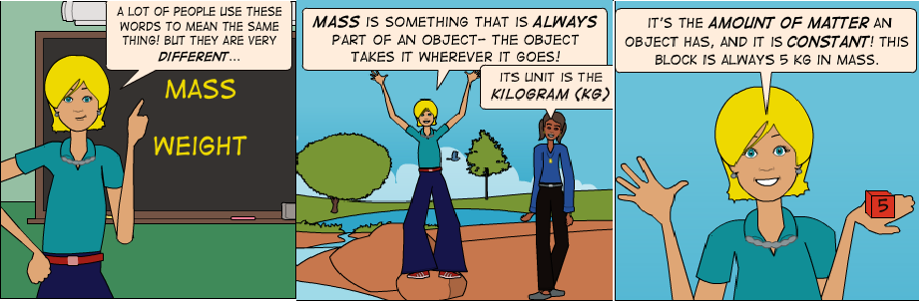
Activity
Circle the object in each box with the greater mass.
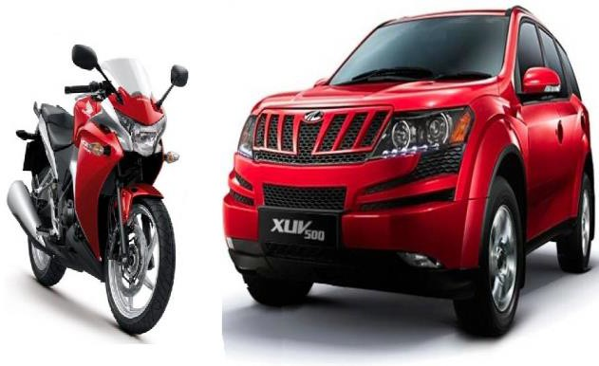
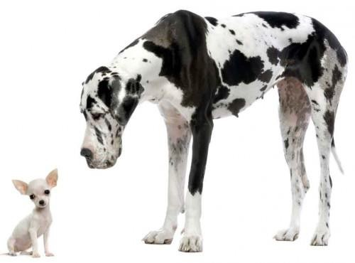

Gravity
All objects with mass have gravity.
All objects have a force that attracts them towards each other. This force is called gravity.
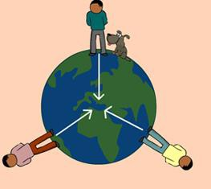
The force of gravity increases when:
• the mass is big
• objects are close.

Even we attract objects to us because of gravity, but because our mass is so small, the force is not very strong.
Gravity is noticeable when there is a really massive object, such as the moon or a planet.
Gravity is a natural force that acts at a distance and does not need direct contact between the objects to function.

Gravitational force pulls in the direction towards the centre of the Earth. We are pulled towards the ground because of gravity.

Why is gravity important?
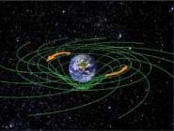
Gravity is important to our everyday lives. It’s what stops you flying off the Earth into space. Without gravity everything would have to be strapped down.

• It keeps the atmosphere around the Earth, so we have air to breathe.
• Gravity keeps the Earth in orbit around the sun, so that the Earth stays just the right distance from the sun. This gives life on Earth light and warmth to survive.
• Gravity between the Earth and the moon creates ocean tides.

Gravity and Unbalanced Forces
F

Gravity is the reason an object falls towards the earth when it is dropped.

The gravity force acting downwards on this ball is larger than the forces acting upwards. This causes the ball to fall towards the ground.

The forces are unbalanced.

Gravity is also the force responsible for creating ocean tides.
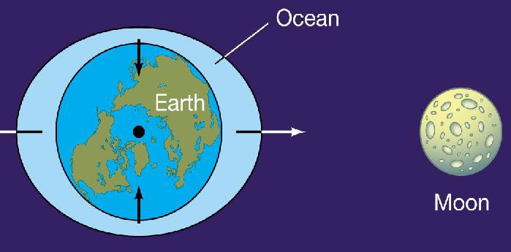
The gravitational attraction between the Earth and the moon is strongest on the side of the Earth facing the moon. The force pulling the water towards the Moon is stronger than the other forces and this causes the water to be pulled towards the moon, creating a swell and changing the tides of the water.
The water facing the moon swells because of the force of gravity acting at a distance between the water and the moon.

The forces are unbalanced.

Activity - Circle true or false for the statements below.
1. Gravity is a force of attraction. true / false
2. The amount of gravity depends on the amount of mass. true / false
3. The closer 2 objects are, the weaker is the force of gravity. true / false
4. The force of gravity needs to be applied directly to an object. true / false
5. Objects move because forces are unbalanced. true / false

Gravity and Weight

Weight is a force caused by gravity. The weight of an object is the gravitational force between the object and the Earth.
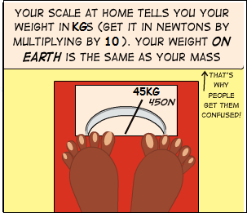
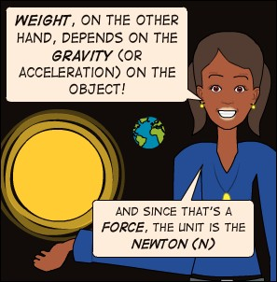
The more mass the object has the greater the weight will be. Weight is a force and is measured in newtons (N).

On Earth, an object with a mass of 1kg has a weight of about 10N.

Gravity, Weight and Mass

The mass of an object stays the same wherever it is, but the weight of an object can change. This happens if the object goes some place where gravity is stronger or weaker.

The Moon has less mass than the Earth, so its gravity is less than the Earth’s gravity.
This means that an object will weigh less on the Moon than on the Earth.
A mass of 1kg has a weight of about 10N on Earth.
A mass of 1kg has a weight of about 1.7N on the Moon.

For example, an astronaut with a mass of 120kg has a weight of 1200N on Earth, but his weight is only 200N on the moon.

Weight on Earth = mass x 10 Weight on the moon = mass x 1.7
= 120 x 10 = 120 x 1.7
= 1200N = 204N

Activity

1. Calculate the weight of the astronaut on Earth and on the Moon if he has a mass of 80kg.

- Weight on Earth = mass x 10 ___________________________________

- Weight on the moon = mass x 1.7 __________________________________

2. Why is the weight of a person different on the moon compared to Earth?
__________________________________________________________________________________________________________________________________________

3. What is the difference between weight and mass?
__________________________________________________________________________________________________________________________________________

4. (a) What force is the reason you fall back towards a trampoline after jumping?
_____________________________________________________________________

(b) Are the forces balanced or unbalanced when you fall towards the trampoline?
_____________________________________________________________________

