Year 8 Science Stage 4 Course
Modified by Mr Danic and Mr Planting, Forces Part 2

Acknowledgments
Sydney Distance Education High School gratefully acknowledges the following owners of copyright material.
Board of Studies NSW Science K-10 Syllabus 2013 NSW Department of Education and Communities Centre for Learning Innovation
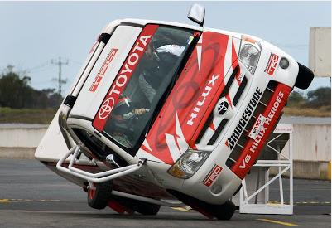
NOTICE ON MATERIAL REPRODUCED OR COMMUNICATED UNDER STATUTORY TEXT AND ARTISTIC LICENCE
FORM OF NOTICE FOR PARAGRAPH 135ZXA(a) OF COPYRIGHT ACT 1968
COMMONWEALTH OF AUSTRALIA
Copyright Regulations 1969 WARNING
This material has been reproduced and communicated to you by or on behalf of Sydney Distance Education High School pursuant to Part VB of the Copyright Act 1960 (the Act).
The material in this communication may be subject to copyright under the Act. Any further reproduction or communication of this material by you may be subject to copyright protection regulation under the Act.
Do not remove this notice.

Copyright of this material is reserved to the Crown in the right of the State of New South Wales. Reproduction or transmittal in whole, or in part, other than in accordance with provisions of the Copyright Act 1968 is prohibited without the written authority of Sydney Distance Education High School.

Glossary
Read through this list of terms and their meanings which are introduced throughout this unit.
Term | Meaning
air resistance | A frictional force slowing the movement of an object as is moves through the air.
force | Anything that causes a change in the motion or shape of an object.
friction | A force that slows things down or stops things moving.
lubricate | To apply a liquid substance to make surfaces smoother and reduce friction.
reduce | To decrease the amount.
streamline | To alter the shape of something to produce the least amount of resistance by air, water, etc.

Lesson 1 -Friction
Friction is a force that slows things down or stops things moving.
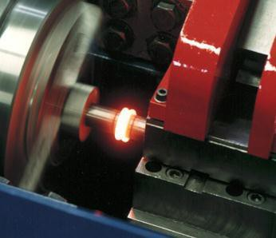
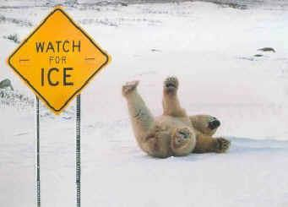
Friction happens when two surfaces are rubbed against each other.
When you walk there is friction between you and the ground.
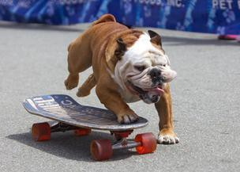
If there was no friction, your feet would not grip the ground and they would slide out from under you when you walk.
When you skateboard on a smooth concrete path you are able to move quickly, but if you ride onto the grass, your speed changes and you might even stop.
This has happened because the surface you were on has changed. The friction of the surfaces is different.
There is more friction on a rough surface than a smooth, slippery surface.

If you are trying to slow down, friction works with you and helps, but when you try to speed up, friction works against you and makes it more difficult.
Activity
1. What is friction? __________________________________________________ _____________________________________________________________________
2. More friction makes it easier to slow down / speed up. (Circle correct answer)

3. Scan this QR code with your smartphone. [You will need a QR reader app]
Or visit website
https://www.bbc.co.uk/bitesize/topics/zsxxsbk/articles/zxqrdxs
The video will not play but have a go at the skiing game down the page.
(a) Which surface produced the least friction?
_____________________________________
(b) Which surface produced the most friction?
_____________________________________

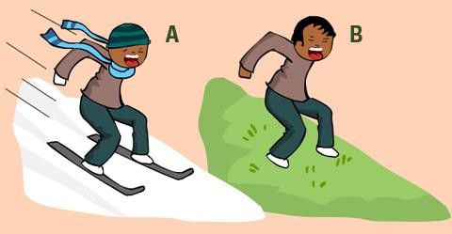
4. (a) In which picture is there more friction? A / B
(b) Explain your choice. ____________________ ___________________________________________ ___________________________________________
Experiment 1
Aim: To observe which surfaces have the most friction.
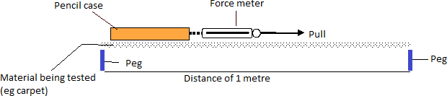
Materials: Pencil case, force meter, ruler, 2 pegs, different surfaces (eg carpet, tiles, concrete, wooden floor, kitchen bench)

Method
- Attach the hook on the force meter to the zipper on your pencil case.
- Use the ruler to measure a distance of 1 metre on your first surface and use the pegs to mark each end of the 1 metre.
- Slowly pull the force meter the distance of 1 metre and record the force needed to move the pencil case. (HINT: For a fair test, make sure you pull the force meter at the same speed for each surface).
- Repeat with the two remaining surfaces.
Results Complete the table below for each surface tested.
Type of surface | Force needed to pull the pencil case (N)

Conclusion
The ______________________ surface had the most friction.
The ______________________ surface had the least friction.

Lesson 2 - Helpful Friction
Friction can be helpful when we want to be slowed down and make our movements more controlled.

Life would be very difficult without friction.
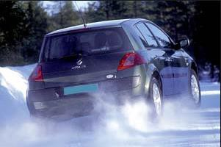
It is the friction between the floor and the soles of your feet or shoes which allows you to walk. Without friction, you would slip and slide over the floor.
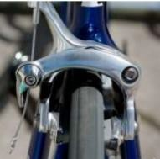
Without friction between car tyres and the road, a car would skid over the surface. You may have seen this happen on wet roads (this is because water and ice reduce friction).
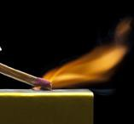
Brakes also work by friction. When brakes are pressed they rub against a rough surface. This produces friction and slows down the wheels.
You also need friction to light a match. The match rubbed against a rough surface produces friction and heat and this causes the match to light. If you strike a match on a smooth surface it will not light.
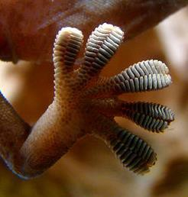
Friction is also useful in nature. The foot of a gecko increases the friction between the foot and a surface and helps to allow the gecko to climb straight up a wall.

Unhelpful Friction
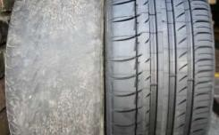
Friction makes surfaces wear down.
The soles of your shoes get worn out due to friction.
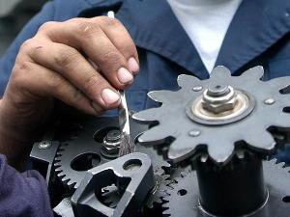
Machine parts which rub against each other also get worn out.
If you don’t lubricate your bike with oil, the friction in the chain and axles increases and your bike will be noisy and difficult to pedal.
Friction also wastes energy. When you ride a bicycle, you use energy to overcome the friction between the moving parts of the bicycle.

Activity 2
1. Rub an eraser (rubber) quickly over a piece of paper. What do you notice happening? ________________________________________________________________
2. Now rub the same eraser quickly over a rough surface, such as concrete. What do you notice happening now? ___________________________________________________ ____________________________________________________________________
3. Which surface will wear down the eraser more quickly? smooth / rough
4. Which surface had the most friction? __________________________________

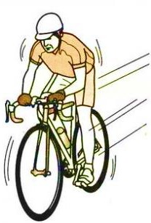
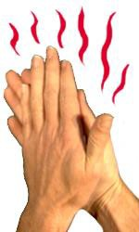
Friction causes heat
Another disadvantage of friction is that is can cause heat. When there is a lot of friction between moving parts, energy is lost to the surroundings as heat.
The brakes on your bike will be hot after they have slowed down the moving wheel.
If you rub your hands together hard the friction will make them get hot.

Activity 3
1. Rub your hands together quickly. What do you notice? _______________________
2. What force causes the heat? _______________________
3. Can you think of any other times when friction causes heat? ___________________
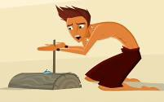
***Bonus with parental supervision only! ***
Try to see if you can start a fire by rubbing dry sticks together. Please do this safely and with means to put out any potential fire. You could use an electric drill if careful to increase your chances of it working.

Lesson 3 – Air resistance
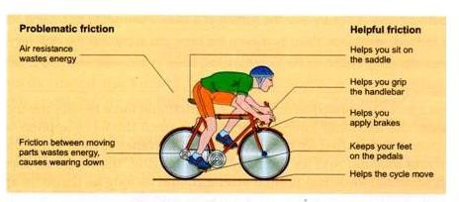
As an object, such as a bike, moves through air, a frictional force called air resistance slows movement.
Air resistance acts in the opposite direction to the way an object is moving. The faster it moves, the greater the resistance.
Air resistance wastes energy because the resistance must be overcome to be able to move forward.

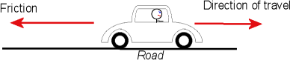
Activity 4 - Look at the picture of a man driving his car on a road. Circle the correct word in each sentence.

- The man is driving his car towards the right / left.
- The force of friction pushes him to the right / left.
- Tyres on a rough road produce more / less friction.
- Air resistance causes the car to move more slowly / quickly.
- If he was driving on an icy road, there would be more / less friction.
Reducing Friction
Sometimes we need to prevent or reduce the amount of friction between surfaces that touch so it is easier to move.
A good example of this is a ball or wheel. They roll to help reduce friction.

Look at the garbage bins in the pictures below. The bin without wheels is big and heavy and the ground is rough. This bin would be very hard to move.
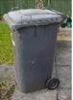
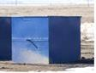
The bin with wheels would be easier to move. There is less friction between the wheels and the ground.

Lubrication
Lubrication is another way to make a surface smoother and reduce friction.

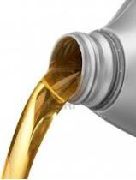
A lubricant is a slippery substance designed to reduce the friction between surfaces. You might use oil to stop a door squeaking. Water can also be used as a lubricant – think about how slippery a floor can be after being mopped.
Machines and engines use grease and oil to reduce friction and wear so they can last longer.
Making things slippery
An iron weight will slide more easily down a slope if it has oil spread underneath it. Adding a layer of oil in between two surfaces makes them slippery and reduces friction. This is called lubrication.
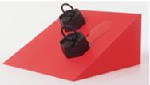
Experiment 2
Aim: To analyse how lubricants reduce friction between two objects.
Method: The time taken for a coin to slide down a ramp was recorded. The process was repeated using water as a lubricant and oil as a lubricant. The results are outlined in the table below.
Lubricant | Time taken for coin to slide down ramp
None | 5 seconds
Water | 4 seconds
Oil | 2 seconds
Results
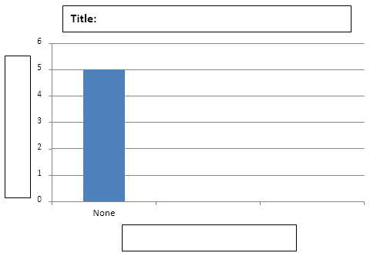
Graphing Results (Complete the column graph to show the results.).

Conclusion (Write whether a lubricant increases or reduces friction between surfaces)
__________________ __________________ __________________ __________________ __________________ __________________
Activity 5
1. Look at the situations in the table below and circle whether you think there is a lot of friction or a little friction for each.
Situation | How much friction? Little or Lot
Bike tyres on a rough dirt road
Bald tyres on a wet road
Riding a bike against the wind
Thongs on mud
Riding a bike with the wind
Skis on snow
Moving a bin with no wheels
2. Describe a situation when friction is helpful. ______________________________ _____________________________________________________________________
3. Describe a situation when friction is unhelpful. _____________________________ _____________________________________________________________________
Reducing Air Resistance
Bikes, cars and other vehicles experience air resistance in the opposite way to which they are moving. This is caused by the frictional forces of the air against the vehicle.
The faster the vehicle moves, the bigger the air resistance becomes.
We can reduce air resistance or ‘drag’ by streamlining an object.
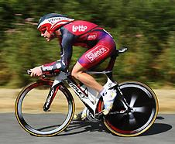
- Racing cyclists crouch down low on their bikes to reduce the air resistance on them. This helps them to cycle faster.
- Cyclists also wear streamlined helmets with a smooth shape that allows the air to flow over them more easily.
- Modern cars are also streamlined. Their smooth shapes make the air resistance smaller, which allows them to travel further on the same amount of petrol.
Activity 6
Find a picture on the internet of a vehicle (eg car, plane) designed to reduce air resistance. Print and paste your picture in the box below. If you do not have internet access, draw a picture of a streamlined vehicle in the space below or in your book.

