Year 8 Science Stage 4 Course
Modified by Mr Danic and Mr Planting, Forces Part 3

Acknowledgments

Sydney Distance Education High School gratefully acknowledges the following owners of copyright material.
Board of Studies NSW Science K-10 Syllabus 2013 NSW Department of Education and Communities Centre for Learning Innovation
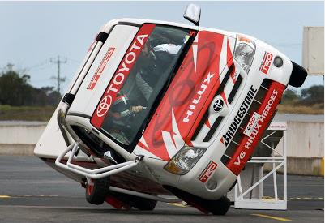
NOTICE ON MATERIAL REPRODUCED OR COMMUNICATED UNDER STATUTORY TEXT AND ARTISTIC LICENCE
FORM OF NOTICE FOR PARAGRAPH 135ZXA(a) OF COPYRIGHT ACT 1968
COMMONWEALTH OF AUSTRALIA
Copyright Regulations 1969 WARNING
This material has been reproduced and communicated to you by or on behalf of Sydney Distance Education High School pursuant to Part VB of the Copyright Act 1960 (the Act).
The material in this communication may be subject to copyright under the Act. Any further reproduction or communication of this material by you may be subject to copyright protection regulation under the Act.
Do not remove this notice.

Copyright of this material is reserved to the Crown in the right of the State of New South Wales. Reproduction or transmittal in whole, or in part, other than in accordance with provisions of the Copyright Act 1968 is prohibited without the written authority of Sydney Distance Education High School.

Glossary
Read through this list of terms and their meanings which are introduced throughout this unit.

Term | Meaning
balanced force | When there is no net force acting on an object.
crumple zone | Areas of a car that are designed to collapse in a collision.
force | Anything that causes a change in the motion or shape of an object.
friction | A force that slows things down or stops things moving.
impermeable | A material that liquid and gas cannot pass through.
permeable | A material that liquid and gas can pass through.
solution | Solving a question or a problem.
unbalanced force | When there is a net force acting on an object causing a change in motion.

Lesson 1 – Technology Developments

This week we will be investigating some technological developments that have contributed to finding solutions to reduce the impact of forces in everyday life. These developments have made activities that we do safer and easier.

Shoe Development
Different shoes have been designed for specific reasons to reduce the impact of forces.

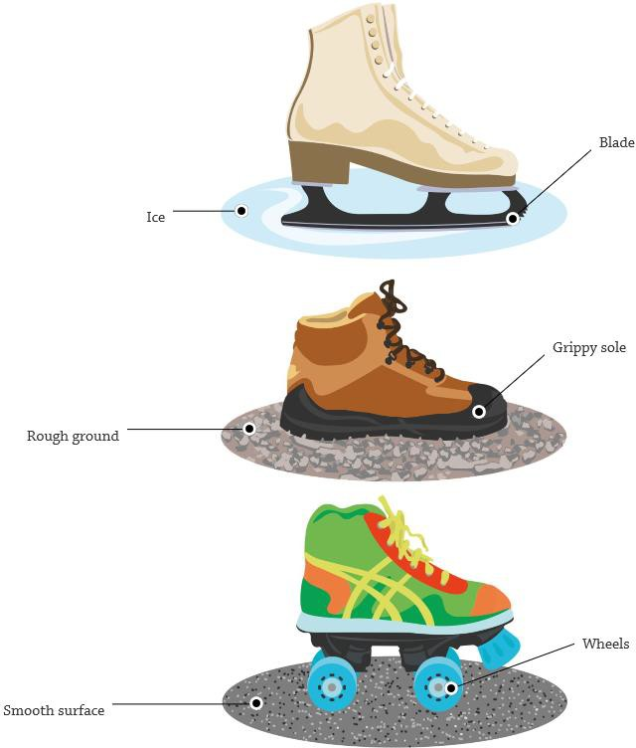
Ice skates are designed to skim over the ice and reduce friction. They melt a little patch of ice underneath them into water, to make the ice even more slippery.

Walking boots are made with thick rubber soles, to make as much friction as possible with the ground. This is to stop people slipping on sloping or uneven surfaces.

Roller skates use wheels to reduce friction. Instead of sliding along, the wheels roll so that they do not drag against the ground.

Activity 1 - Choose one of the shoe styles below and answer the questions.

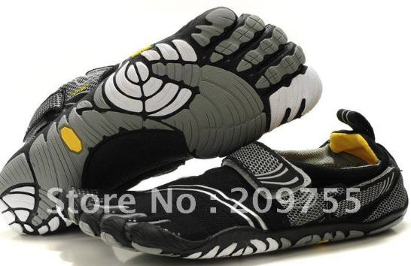
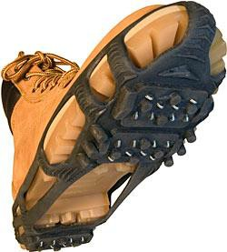
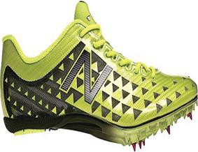
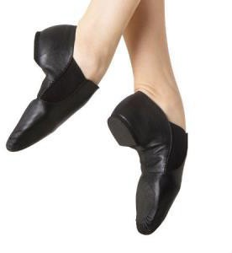

Sprinting shoes Dancing shoes Rock climbing shoes Ice shoes
1. Shoe type: ____________________________
2. Is the shoe trying to increase or decrease friction with the ground? _____________
3. What features of the shoe make it suitable for its purpose? __________________ _____________________________________________________________________
4. What do you think a shoe that was designed to slide on carpet would look like? Draw the shoe (or write about it) in the box below.

Helicopters
Helicopters have been designed in a way to balance the forces acting on the helicopter to allow it to hover still in the air, as well as move throughout the sky.
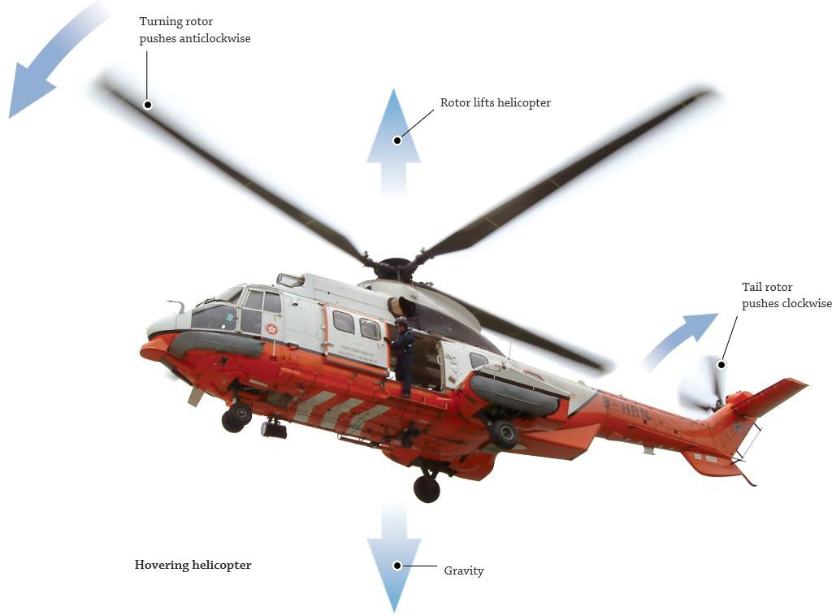
As the rotor spins, it pushes air downwards, lifting the helicopter upward. If the upward force of the rotor equals the downward force of gravity, the helicopter will stay in the same place without moving up or down.
The rotor not only pushes the helicopter upwards it also tries to spin it around. Another force is required to keep the helicopter steady.
The smaller, tail rotor pushes the helicopter clockwise. This balances out the turning force created by the main rotor, stopping the helicopter from spinning round in circles.
The force of gravity pulls the helicopter down towards the ground. The helicopter will fall downwards unless it uses its rotors to create an upwards force to balance out the force of gravity.
Experiment 1

Aim: To build a helicopter.
Materials: Cardboard (from a cereal box or something similar), 3 pencils (2 short and 1 long), strong sticky tape, scissors

Method
- Tape the three pencils together. Two short pencils on either side of the longer one. This is the launcher.
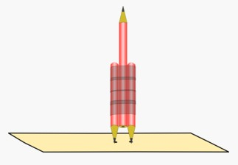
- Cut a piece of cardboard 2cm by 10cm.
- Use the taped pencils to mark 2 points either side of the centre on the piece of paper. Use a pencil to punch holes in the cardboard at these two points.
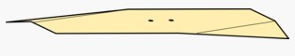
- Make sure that the launcher pencils fit into the cardboard loosely, so that the card can lift off easily.
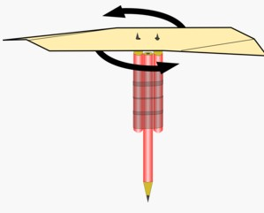
- Make two diagonal folds in the cardboard on opposite corners. Make sure the flaps point downwards.
- Put the piece of card on the launcher and spin. It may take a few tries to get the paper to lift from the pencil launcher.

Observations
Write what you saw happen. __________________________________ ________________________________________________________ _____________________________________________________________________

Explanation
The card moves through the air like a rotating wing when you spin it. There are forces acting upwards and downwards on the wing, and when these are balanced, the wing is able to hover in the air.

***Extra***
Try to modify and improve on the design. You could use rubber bands to store energy and release it quickly or a string wrapped around the pencils to be pulled away quickly, like a ripcord on a lawn mower.

Lesson 2 – Forces in Sport
There are balanced and unbalanced forces during sport. Think about when you kick a ball, you need to apply force with your foot to move the ball forward or change its direction.
The study of forces in sport has led to changes in equipment, clothing, etc.
The mind map below outlines some of the forces during a game of baseball.

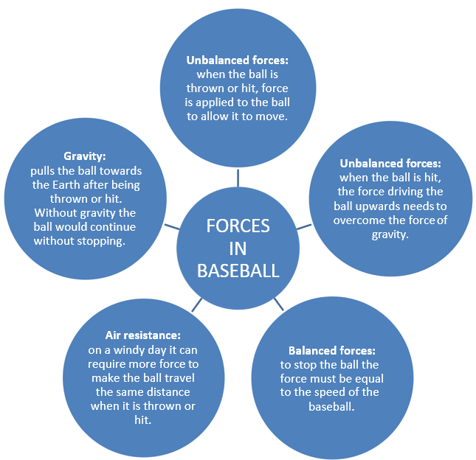

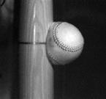
Did You Know?
When a bat hits a ball in baseball, the ball can change shape slightly as a result of the applied force from the bat?

Activity 2
Choose a sport where you can observe forces. Create a mind map similar to the one above outlining any balanced or unbalanced forces. You can use the template below or create your mind map using Microsoft Word (or a similar software) and attach to this page.
The following websites provide information about the forces in sport.
• http://www.exploratorium.edu/theworld/surfing/physics/index.html
• https://prezi.com/_ubwyddtgyes/balanced-and-unbalanced-forces-sports/
• http://www.exploratorium.edu/skateboarding/trick02.html
• https://prezi.com/xzemdl4bq0cn/physics-behind-ballet/

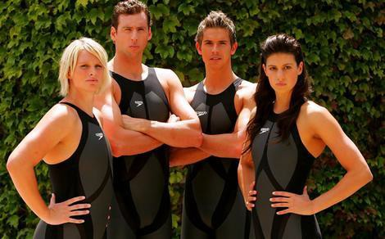
Swimsuit Design
In recent years there has been a lot of research into making better swimsuits. Scientists spend time and money making our swimmers faster in the water.
The ideal swimsuit reduces the amount of drag and friction created by the water as the swimmer moves through it.

In 2009 at the World Championships in Rome, a new style of swimsuit was worn by some of the competitors. The swimsuit has now been banned as officials felt it gave swimmers an unfair advantage.

Activity 3 – Scan this QR code with your smartphone. [You will need a QR reader app]

Or visit website http://www.abc.net.au/btn/story/s2639915.htm
Listen to the recording, or read the transcript, and answer the questions below.
1. Is the new swimsuit permeable or impermeable? ____________________________

2. How does the swimsuit reduce friction and drag? ___________________________ _____________________________________________________________________
3. (a) Do you agree that the swimsuit should have been banned? Yes / No

(b) Write a reason for your answer. _________________________________________ _____________________________________________________________________

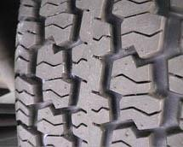
Lesson 3 – Car safety Developments – Tyres
Friction is extremely important on a slippery road. If the road is too slippery, the tyres slide or skid.
Friction between the tyres of a car and the road determines how quickly a car accelerates and, more importantly, the time it takes for a car to stop.
Research has shown that the tread on tyres needs to be suitable for the road and conditions.
Most cars on the road will need to cope with all weather situations, e.g. wet, dry, etc. This is why tyres on cars have a large amount of tread pattern. This increases the friction between the tyre and the road and allows the car to better grip the surface in all conditions.
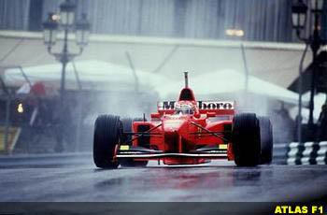
Formula One
Tyres are extremely important in car racing. Friction between the tyre and road will allow the driver to take a corner more quickly without losing control of the car.
The tread pattern used depends on the track conditions. In Formula One, there are ‘wets’ and ‘slicks’ (tyres with no tread pattern).
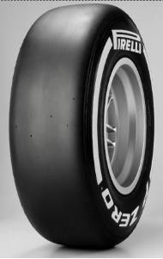
Slicks
Slick tyres work well in dry conditions. As there are no grooves there is less friction between the tyre and the road. This allows the cars to travel faster down the track and when cornering.
Using slicks in wet conditions makes the track like an ice rink and can cause aquaplaning (the wheels of the car lose contact with the road due to water).
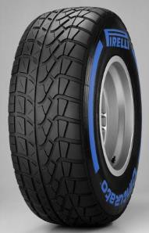
Wets
Formula One racers use wet tyres in wet conditions. Wet tyres have a pattern of grooves to move the water in front of the tyre away to the sides increasing the friction between the tyre and the road. This means the tyre can make contact with the road and allows the car to travel at higher speeds in wet conditions without losing control.

Activity 4
1. Why do tyres on non-racing cars need a large amount of tread pattern?
__________________________________________________________________________________________________________________________________________
2. Why do Formula One race cars not use slicks in wet weather?
__________________________________________________________________________________________________________________________________________

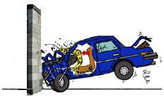
Car Safety Features
When there is a car crash, the passengers continue to move forward until they hit something that stops them. If they stop by hitting the windscreen or steering wheel they can be seriously injured or killed.

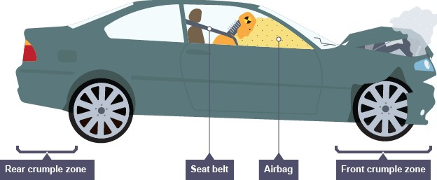
Modern cars have been redesigned to incorporate safety features to minimise the impact of the forces on passengers in an accident. These features include:
• Seat belts
• Air bags
• Crumple zones

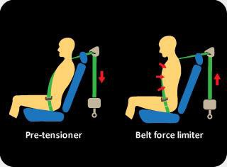

Seat belts
The job of the seat belt is to hold the passenger in place. The seat belt holds the passenger to their seat and stops them flying forward, or out of the windscreen when the car stops quickly.

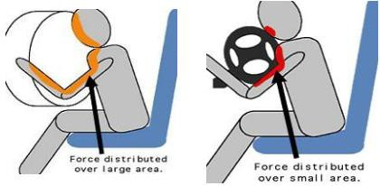
Air bags
When a car is involved in a collision, air bags are used to protect the passengers. Air bags act as a soft cushion to protect your head and chest from injury and spread the force over a larger area, reducing pressure on the body.

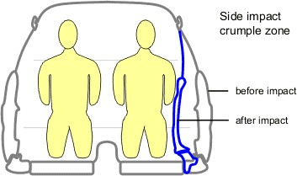
Crumple zones
The shell of a car is usually made from steel to protect its passengers. The engine compartment and the boot are crumple zones that are designed to collapse in a collision. They increase the time taken for the car to slow down in an impact. This reduces the force on the passengers.

Activity 5 – Match the safety feature with its benefits.

Safety Feature | Benefit
Seat belt | Protects your head and chest from injury.
Air bag | Increase the time taken for the car to slow down in a collision.
Crumple zone | Prevent the passenger from flying forward in an accident.

Experiment 2

Aim: To model crash-test dummies and investigate forces and motion.
Materials: toy cars/trucks, plasticine or playdough, talcum powder, ramp (eg a piece of timber), books or bricks, ruler.

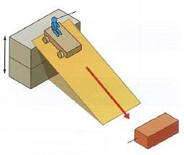
Method
- Make a crash test dummy from the plasticine or playdough.
- Set up a ramp to a height of about 30cm using books or bricks.
- Place a brick or book 10 centimetres from the bottom of the ramp.
- Dust the base of the crash test dummy with a small amount of talcum powder to prevent sticking.
- Put the crash test dummy onto a toy car/truck.
- Place the car/truck onto the top of the ramp and watch the motion of the car and dummy as it travels down the ramp and hits the brick.
- Repeat the test 3 times and record your observations on the next page.
Observations
Test number | Observations (describe what happened to the crash test dummy)
1
2
3

Discussion
Describe what safety features could protect the dummy during impact with the brick.

_______________________________________________________________________________________________________________________________________________________________________________________________________________

Use materials found at home (eg sticky tape, ribbon, etc.) to make your car/truck safer for your crash test dummy. Take a photograph of your car and email to your teacher or submit it with your work in Google classroom.

Extension Activity
Repeat the ramp experiment with the ‘safe’ car you created.
Observations

Test number | Observations (describe what happened to the crash test dummy)
1
2
3

Discussion
1. Did your safety equipment keep your crash test dummy safe? Yes / No

2. What changes would you make to your car to make it safer for your crash test dummy?

_______________________________________________________________________________________________________________________________________________________________________________________________________________
